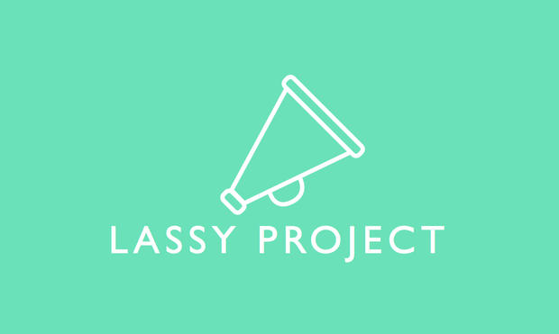
Pace Public Relations is proud to announce its newest client….Lassy Project.
Lassy Project is a free service that gives parents and guardians the ability to notify an entire local community about their missing child in seconds. The service was co-founded by John Guydon, an entrepreneur who was moved to help other parents after the abduction and murder of 10-year-old Jessica Ridgeway happened in his own community.
“I wasn’t set out to start this company, I just wanted to help as a father,” said Guydon. “Details haunted me, I couldn’t sleep, I just kept thinking about what could have happened differently.”
The Lassy Project app can be downloaded for free at the iTunes App Store or on Google Play. However, the smartphone app is not required for you to receive alerts about missing children. You can also sign up for alerts at www.lassyproject.com. As a Lassy user, you can designate a specific “Lassy Village,” or group of friends or neighbors who would be notified if your child ever went missing. When a child is missing, a parent can quickly send out an alert to their village with the child’s last known location. The village is instantly notified via app alert or text message and can begin to search for the child.
Anyone can sign up to be a member of the Lassy Project. Lassy operates in communities across the U.S. and is functional in every state. Lassy Project is also not just for children. Registered users include people who work with adults who have Alzheimer’s, user’s that care for seniors or persons with developmental disabilities, and even women who use the app if they have to walk alone at night.
“We’re so happy to be bringing Lassy Project to Pace Public Relations,” said Annie Scranton, the founder of the firm. “Lassy Project is doing such amazing things for its community and John is making such a difference with this service.”
John can speak further as to his decision to start Lassy Project, how it works, and why it’s a game changer for missing persons cases. For more information about John and Lassy Project or to book him for an interview, contact Annie Scranton at annie@pacepublicrelations.com or call 646-599-9222. You can also find out more about Lassy Project by visiting www.lassyproject.com.

