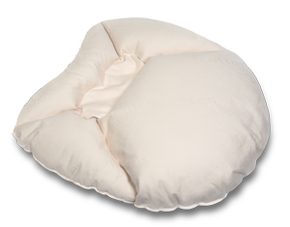
It’s never too early to start thinking about Mother’s Day. Moms can be hard to shop for – but what better gift than one that is both luxurious and supportive of women and breast cancer survivors?
1 in 8 women in the United States will get breast cancer at some point in their life. The Billow Pillow is the first premium breast support pillow for women who have trouble sleeping due to discomfort from surgery.
Billow is ergonomically designed to embrace the user. It was created by Marnie Rustemeyer, who, after being diagnosed with the BRCA (breast cancer gene), made the decision to have a mastectomy and get the subsequent reconstructive surgeries. When she found she was having trouble sleeping after her surgeries, she made it her goal to develop a pillow that would help other women in similar situations.
Billow can help women who are recovering from surgery, but it also can help other women as well. Here are the ways Billow is helping women from all walks of life:
- Billow for Healing
  - Billow has a depressed area for the breasts and provides a soft and supported area post-surgery.
  - Firm support in the torso area of the pillow alleviates pressure on the lower back.
  - Softer filling in the upper arm and neck provides extra relief for those with extreme sensitivity.
- Billow for Curvy Women
  - Depressed area for the breasts provides softness and support for larger-breasted women.
  - The pillow’s softer filling around the neck and arms offers extra comfort while resting on your stomach.
- Billow for Post Natal Women
  - Billow will mold to a woman’s curves
  - Billow’s cushion cradles mothers’ sensitive breasts
  - Billow can be used as a body pillow for pre-natal women.
Billow is designed to make sure users get the utmost comfort from the pillow. Billow is handmade in the U.S. with domestic and organic materials. The outershell is made out of 100% organic cotton and Billow is filled with highly sustainable Eco-PureTM wool. Eco-Pure’s wool is hypo-allergenic, flame-resistant, bug-resistant, and mositure-wicking. Each Billow also comes with two custom-made Billow pillow cases.
Billow retails for $200, but a portion of the proceeds from every Billow gets donated back to charities that focus on cancer research. To find out more about Billow or to book Marnie for an interview contact Annie Scranton at annie@pacepublicrelations.com or call 646-599-9222.

www.breastcancer.org

